|  |  |  |  |  |  |
| --- | --- | --- | --- | --- | --- |
| Date | Dec 9, 2022 | | | Tester Name | Syed Shahabuddin |
| Environment | Penfax - Test | | | Login used |  |
| Operating System | Windows | Version: | Update: | | |
| Software Used | Edge | Version: | Update: | | |
| Select Software | Version: | Update: | | |
| Release version | 22.4.1 | | | | |
| Title | E26.06 | | | | |
| Test Type | Regression | | | | |
| Test Scenario | PEPP Steps rollover for a member in both PEPP and VPB | | | | |
|  |  | | | | |
| Expected Results | That the PEPP steps rollover will complete correctly for both the PEPP and the VPB account on the same day. That the DAI will change accordingly in both accounts.  That there is no other impact & no letter generated due to the rollover. | | | | |
| Pass/Fail | Pass | | | JIRA# | N/A |

To find a member, searched the COVID PEPP folder for “partial vpb”

Note: could also find an active member over 50 and transfer part of the money to VPB.

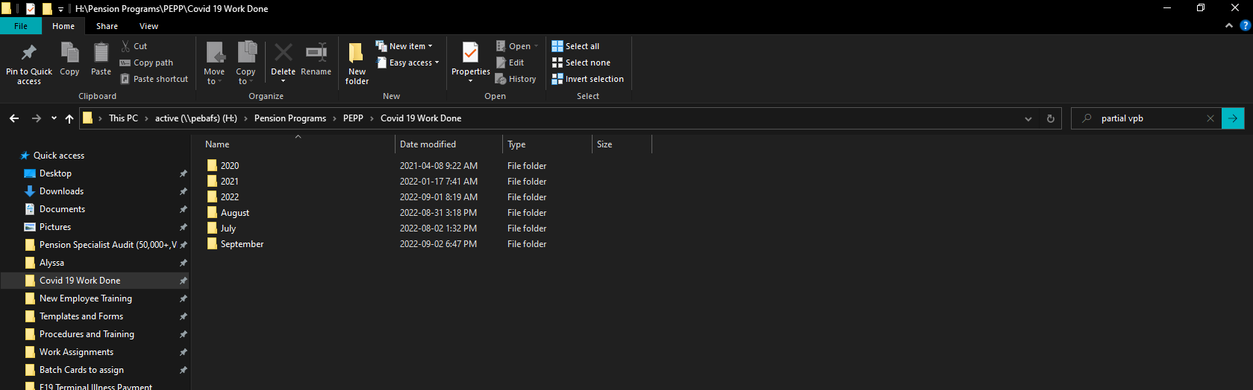

SID 300239

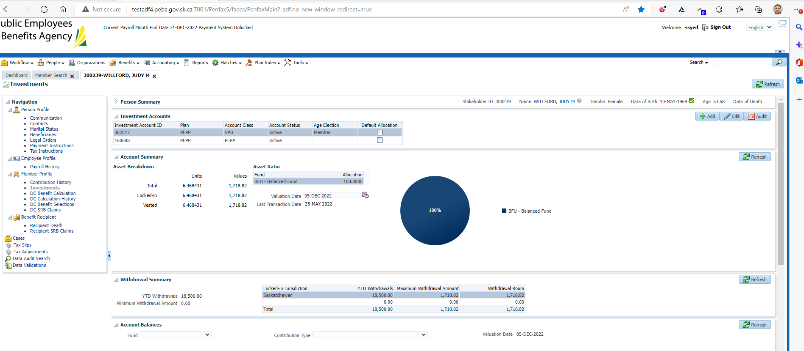

Adding DAI & Processing interfund to PEPP steps (both PEPP and VPB)

PEPP –

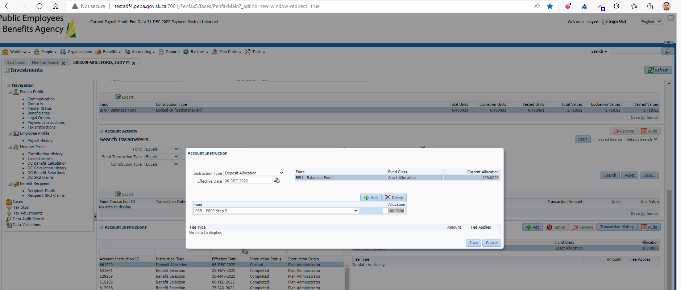

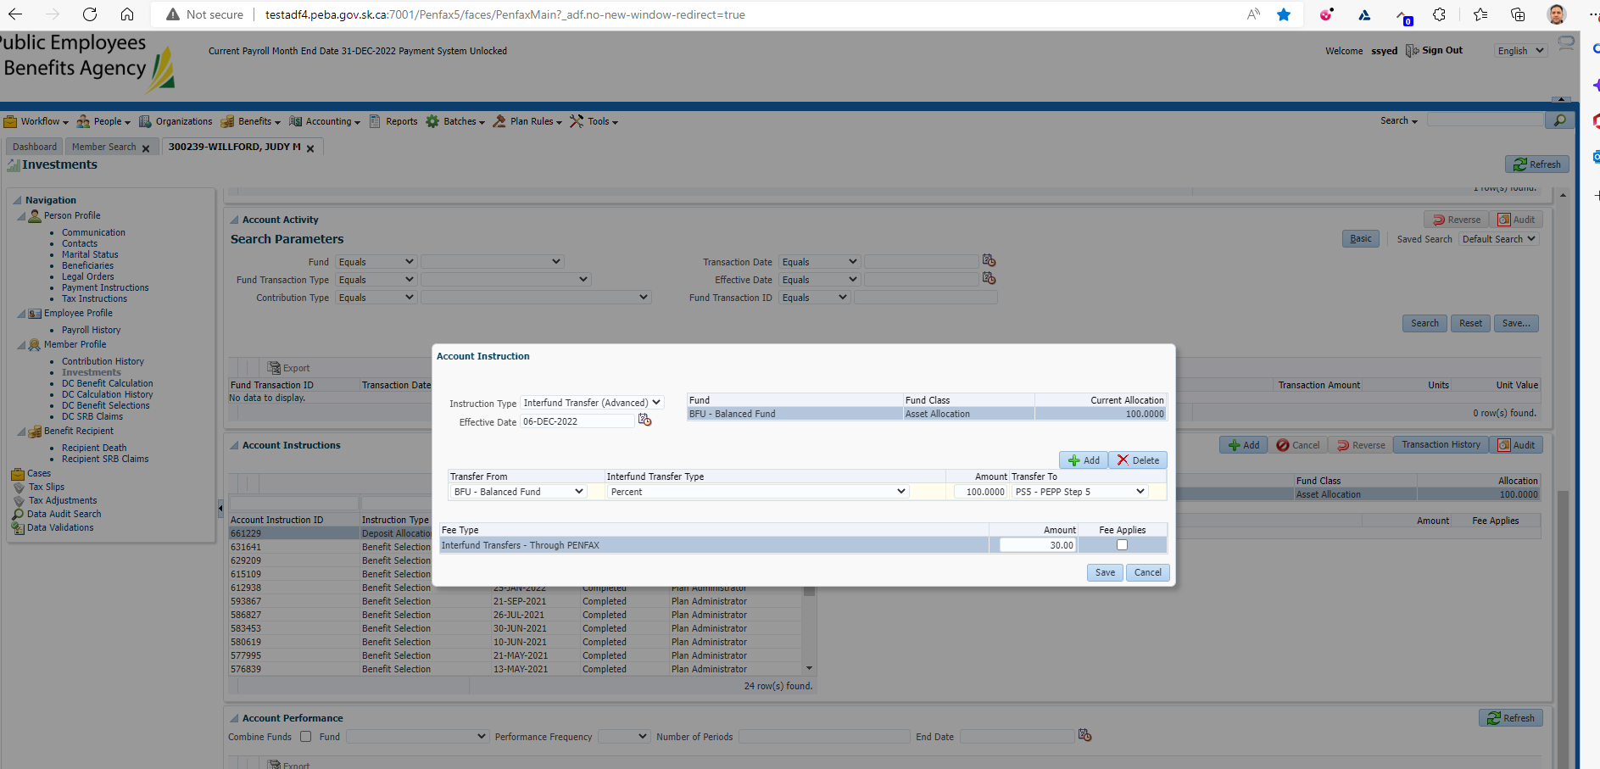

VPB -

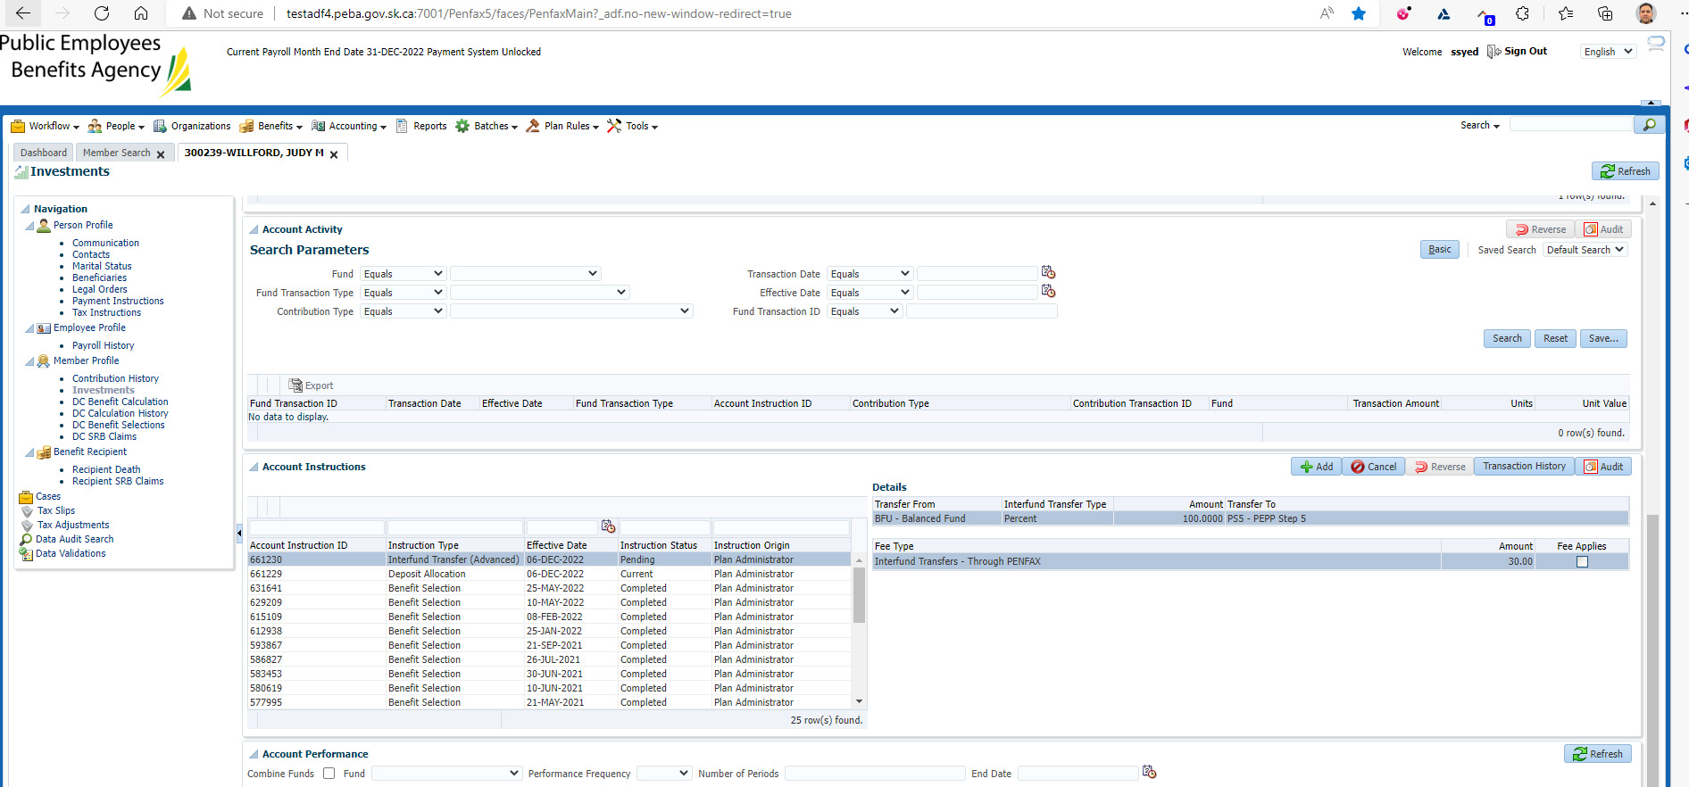

Updated Birthdate to be 54 on Dec 8to move to Step 6 in lifecycle

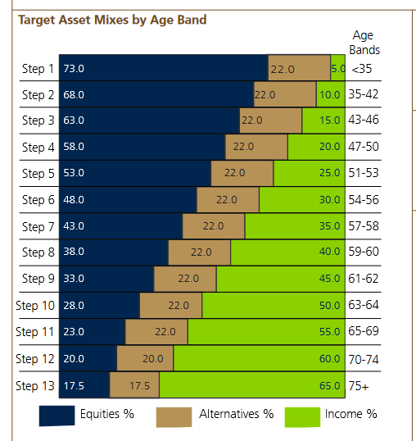

Waiting till 8th to confirm lifecycle results.

Next day confirmed that funds were moved to Step 5 in both PEPP and VPB. Should move to step 6 at 54 (tomorrow):

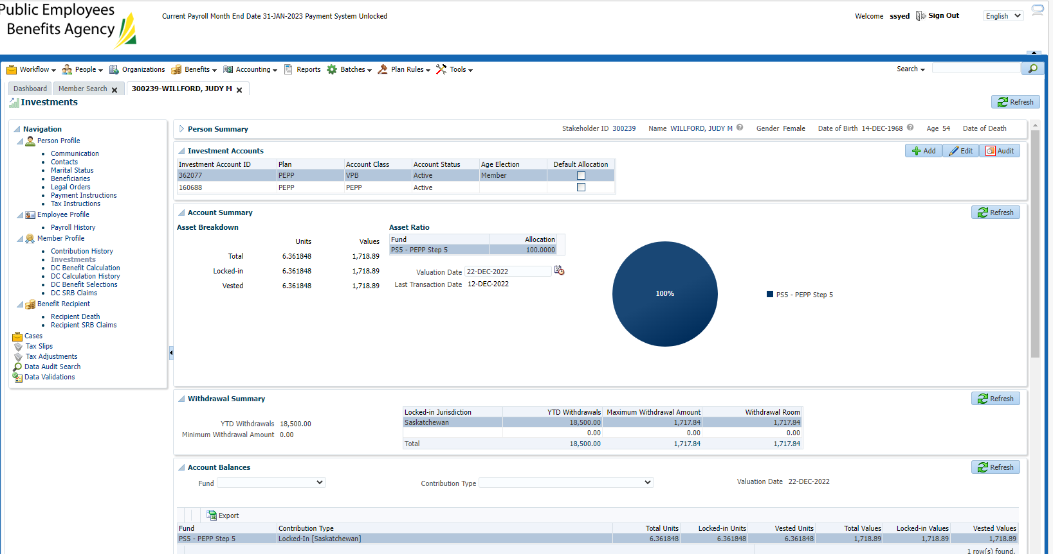

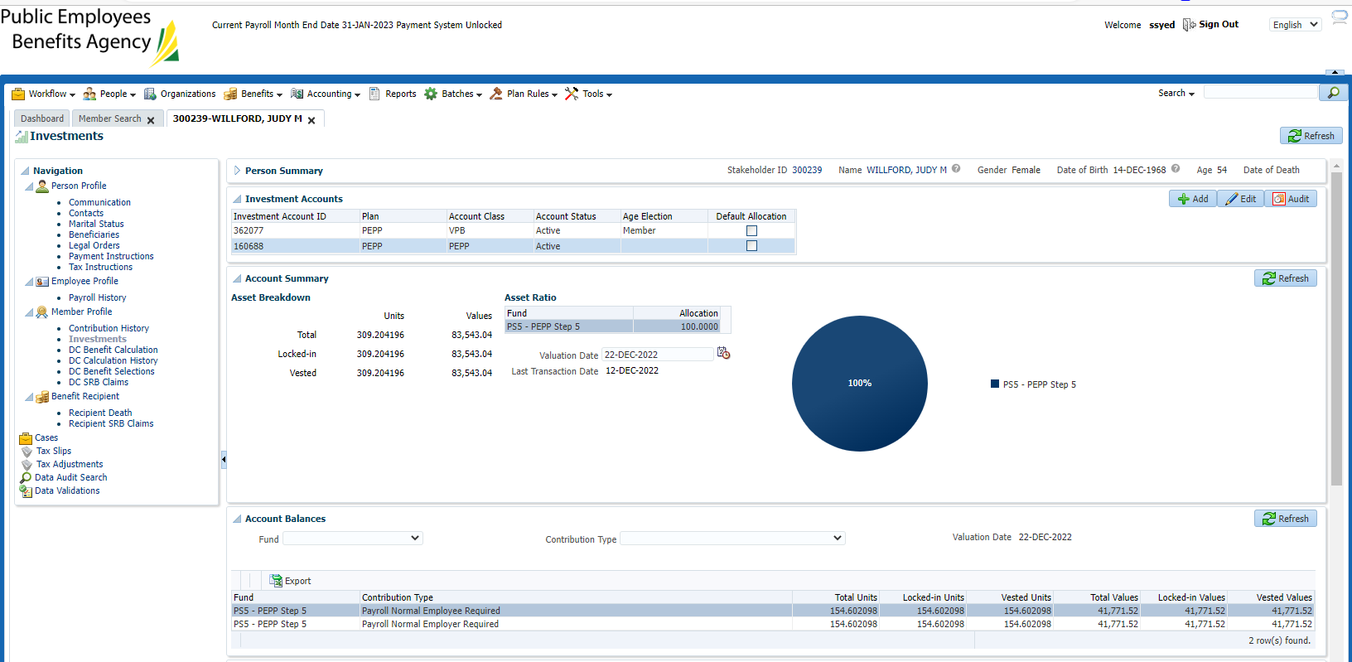

Interfund letter generated, this is correct as it was a user entered interfund (not due to lifecycle):

Letter is very confusing when they are in PEPP and VPB as it shows two balanced funds but doesn’t specify which is PEPP and which is VPB.

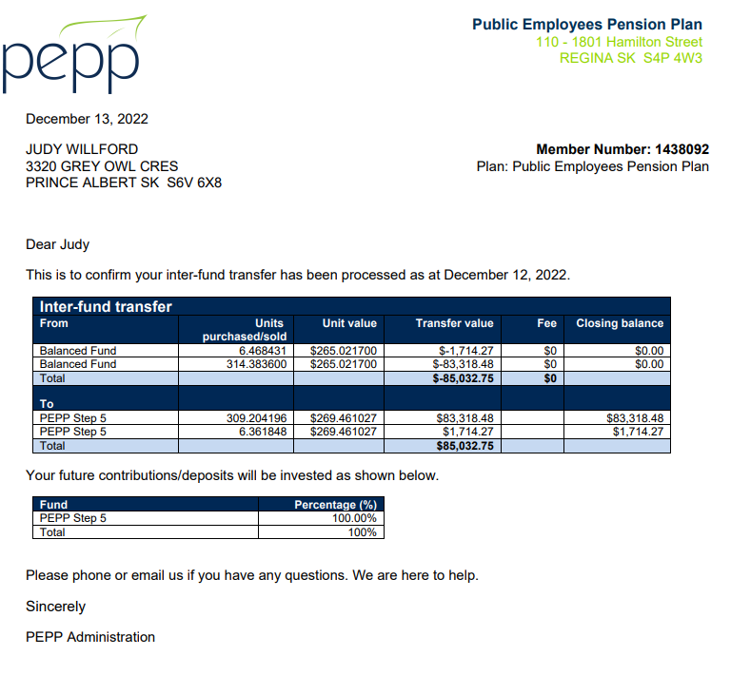

Wait for next day (day 3):

Shows pending transaction for lifecycle batch & new current DAI for the new PEPP step 6 fund.

VPB:

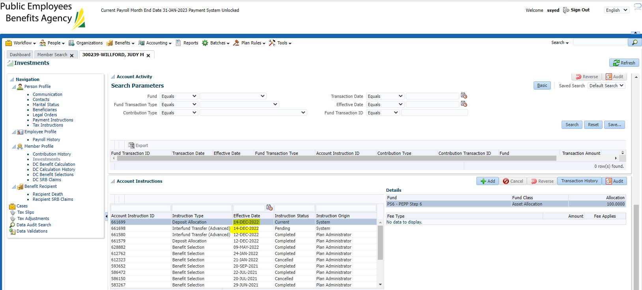

PEPP:

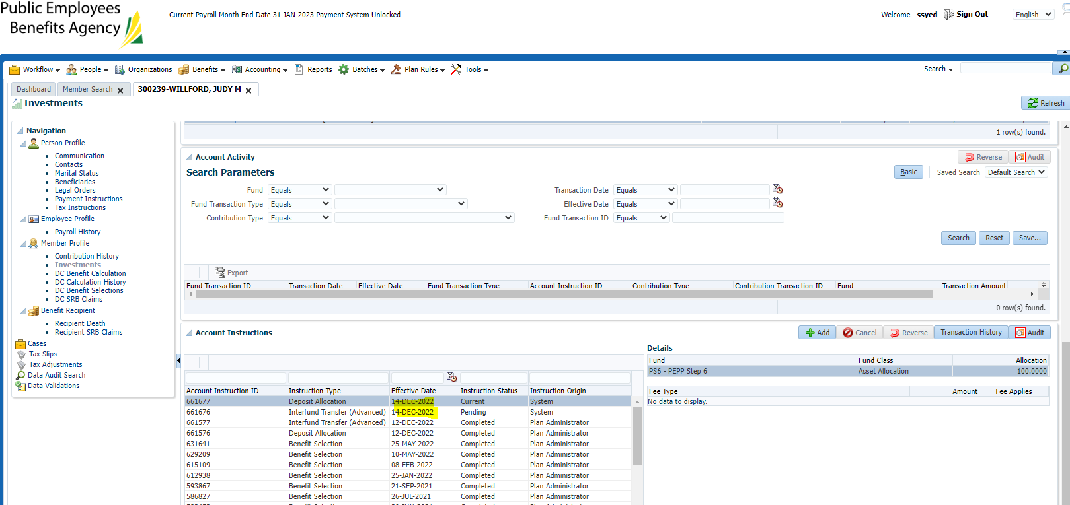

Day 4: Verified that interfund completed, funds moved and no letters generate.

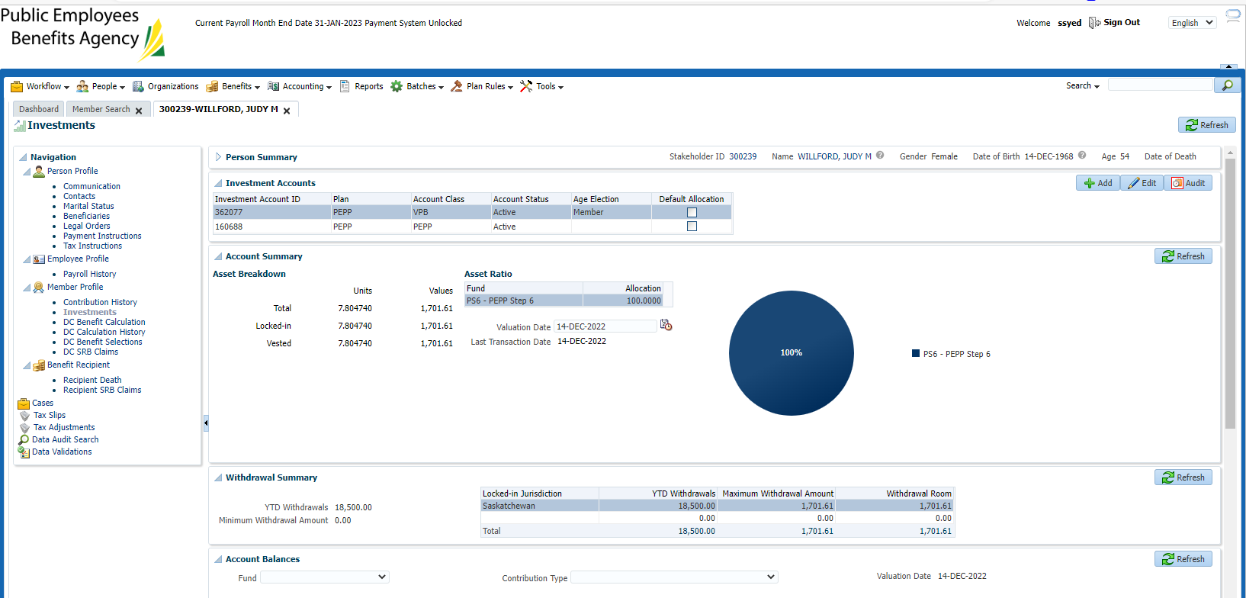

No letters – sept 8th - passed

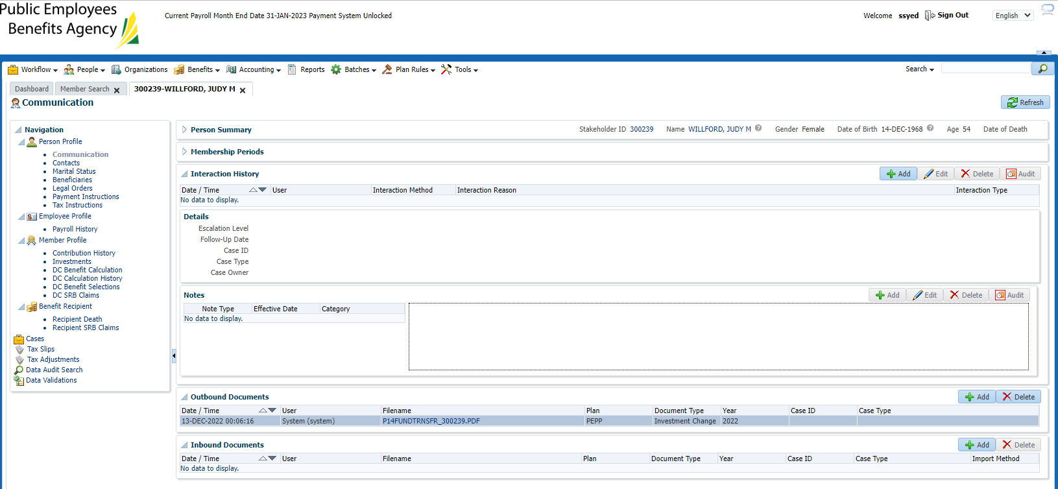

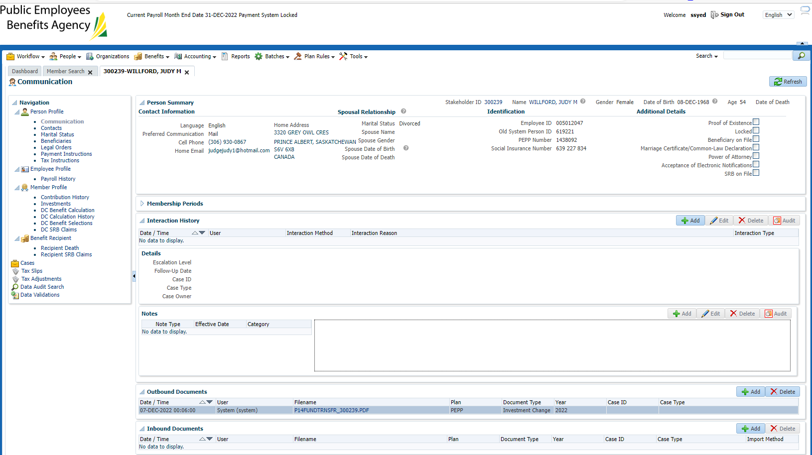

Results as of Dec 8

VPB

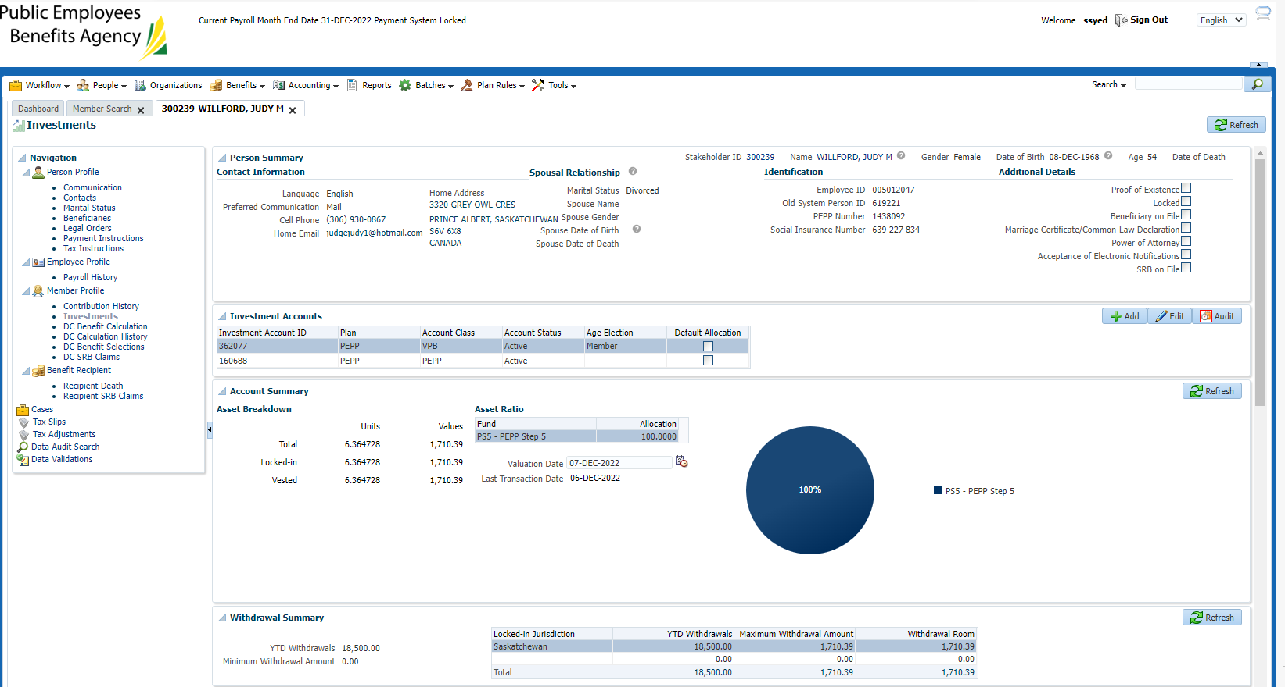

PEPP

